# My weather App: (Using the open weather API)

## Project Code:

|  |
| --- |
| #include<cpprest/http_client.h>  #include <iostream>  #include <string>  #include <vector>  using namespace std;  using namespace web;  using namespace web::http;  using namespace web::http::client;  class Location  {  public:  string name;  };  class weather  {  public:  int temp, windspeed, humidity;  };  int menuform()  {  int menu;  cout << "-----My Weather App-----\n";  cout << "What operation do you want to perform?\n";  cout << "1. Add Cities\n";  cout << "2. See Added Cities\n";  cout << "3. Check Weather\n";  cout << "4. Delete Cities\n";  cout << "5. Exit\n";  cin >> menu;  return menu;  }  int main()  {  Location lc;  vector<string> list;  int choice;  string cityName;  do  {  system("cls");  choice = menuform();  system("cls");  switch (choice)  {  case 1:  {  int n;  cout << "How many cities do you want to add? ";  cin >> n;  cin.ignore(); // To clear the newline character left by cin  for (int i = 0; i < n; i++)  {  cout << "Enter the name of city " << i + 1 << ": ";  getline(cin, lc.name);  list.push_back(lc.name);  }  cout << "***Cities added successfully***\n";  break;  }  case 2:  {  cout << "------List of Cities------\n";  for (int i = 0; i < list.size(); i++)  {  cout << i + 1 << ". " << list.at(i) << endl;  }  cout << "\nPress Enter to continue...";  cin.ignore();  cin.get();  break;  }  case 3:  {  cout << "Enter the city name for which you want to check the weather: ";  cin.ignore();  getline(cin, lc.name);  http_client client(U("https: //api.openweathermap.org/data/2.5"));  uri_builder builder(U("/weather"));  builder.append_query(U("q"), utility::conversions::to_string_t(lc.name));  builder.append_query(U("appid"), U("15b249c4faa994279c71a7714afeb606"));  http_request request(methods::GET);  request.set_request_uri(builder.to_string());  client.request(request).then([](http_response response) {return response.extract_json(); }).then([](web::json::value body)  {  cout << "The city to check the weather is: " << lc.name << endl;  cout << "\tTemperature: " << body[U("main")][U("temp")].as_double() << " k" << endl;  cout << "\tHumidity: " << body[U("main")][U("humidity")].as_double() << " %" << endl;  cout << "\tWeather: " << utility::conversions::to_utf8string(body[U("weather")][0][U("main")].as_string());  }  ).wait();  break;  }  case 4:  {  cout << "Enter the city name you want to delete: ";  cin.ignore();  getline(cin, cityName);  auto it = find(list.begin(), list.end(), cityName);  if (it != list.end()) {  list.erase(it);  cout << "***City deleted successfully***\n";  }  else {  cout << "City not found!\n";  }  cout << "\nPress Enter to continue...";  cin.get();  break;  }  case 5:  {  cout << "Exiting the application.\n";  return 0;  }  default:  {  cout << "Invalid choice! Please enter a number between 1 and 5.\n";  cout << "\nPress Enter to continue...";  cin.ignore();  cin.get();  break;  }  }  } while (true);  return 0;  } |

## Code Snippets:

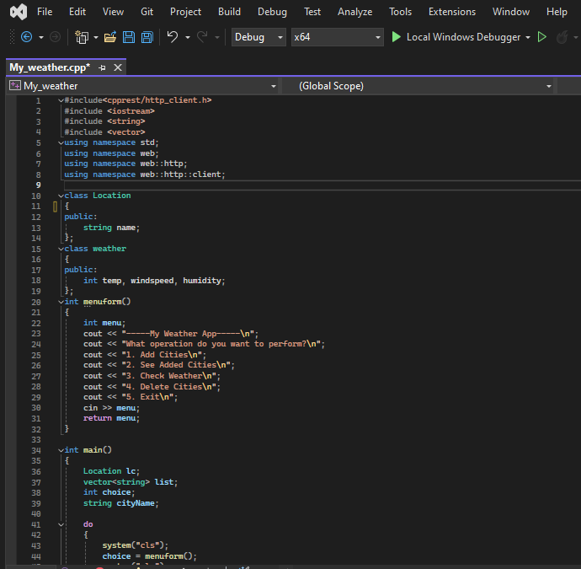

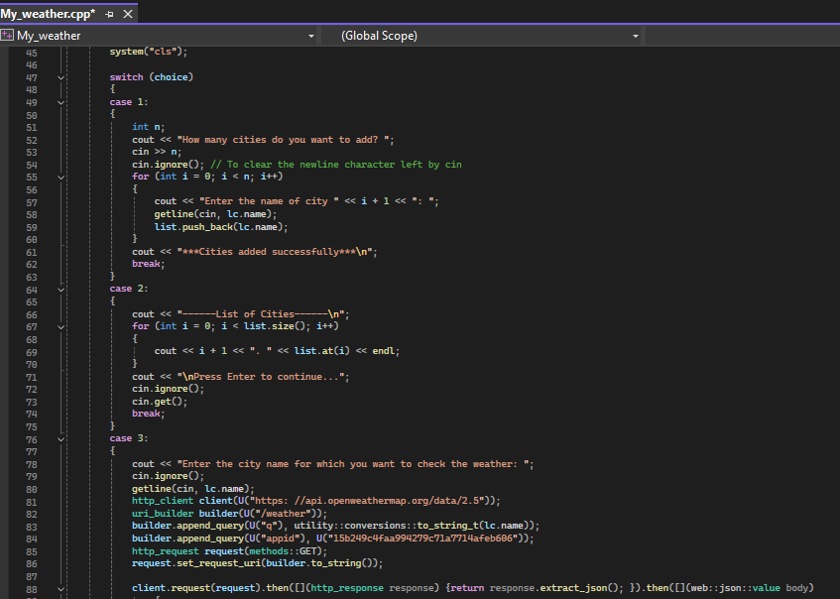

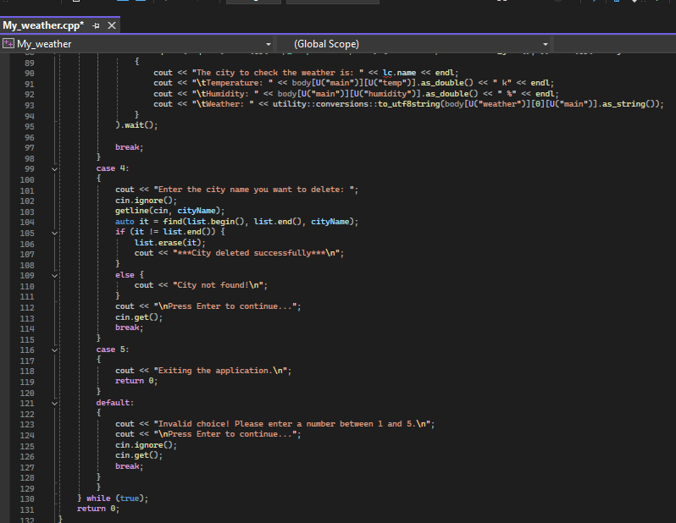

## Issue Description:

I have done this code with my own knowledge and also took help with other websites also for learning the use and implementation of API, so after I compiled my code I faced one issue which was the issue in including the external library (cpprest/http_client.h) this issue is because of some corrupt files in my cmake directory which I tried to solve but it didn’t work and now I am submitting my task with all the tasks done but I’m unable to run and add output screenshots, I will solve this issue in future for my upcoming tasks, you can check and test this on your system. Thank You